Waves - Building Background

Document Overview:

The purpose of this activity is to help students build a background of wave terms and the variables that affect the speed of a wave. This activity involves taking notes from a website to create a foldable flip chart and a hands-on activity or simulation.

Minnesota State Academic Science Standards:

Sound waves are generated from mechanical oscillations of objects and travel through a medium.

9P.2.3.1.1 Analyze the frequency, period and amplitude of an oscillatory system.
9P.2.3.1.2 Describe how vibration of physical objects sets up transverse and/or longitudinal waves in gases, liquids and solid materials.

Objective:
- Students will use a foldable flip chart to take notes about the parts of a wave.
- Students will determine which variables affect the speed of a wave.

Type of Activity:
This activity has two parts, the first is reading a website and building a foldable flipchart. The second part is a hands-on activity with observations and conclusions using a simulation.

Duration: 1 50 minute class period per activity

Teacher Tips:
This is intended as a Nobel Conference building background activity in preparation for later lessons.
Concepts:
- Waves

Description of Activity:
Part A
Students will be given or instructed to make tabbed, foldable flip book as pictured.

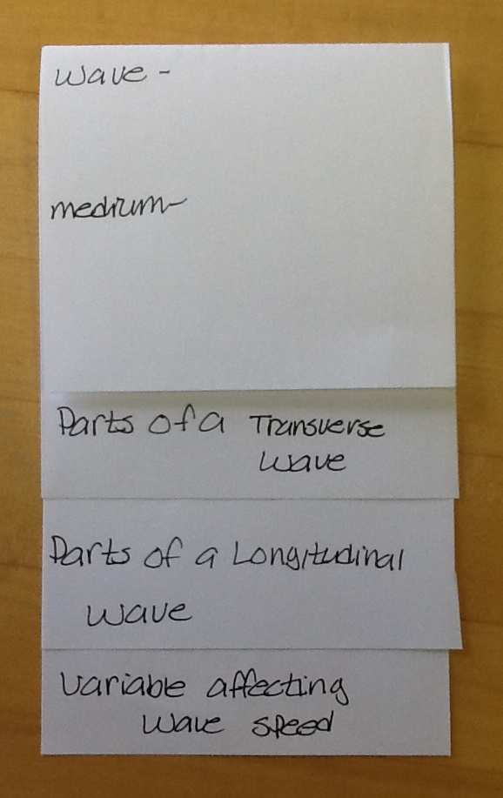 | On the top page students will define the terms wave and medium.  The tab of the second page students should label Parts of a Transverse Wave. On this page they will draw a transverse wave and label the parts.  The 3rd tab should be labeled Parts of a Longitudinal Wave and on this page they will draw and label the parts of a longitudinal wave. Students should also define transverse and longitudinal waves on each of these pages and note how the energy and the particle move on each of their diagrams.  The last tab should be labeled Variables Affecting Wave Speed and they will leave this one blank for now.

Students will complete flip books as they read from the following website:
http://www.physicsclassroom.com/Class/waves/u10l1b.cfm
When finished with this section, at the bottom of the page, click “skip to lesson 2”

Review with students after the reading to make sure they defined terms and labeled everything correctly.

Part B
Variables affecting the speed of a wave

There are 3 options depending on your available resources:

Option 1. Computer simulation
http://phet.colorado.edu/en/simulation/wave-on-a-string

Investigate the effect of amplitude, pulse width and damping on the speed and size of a wave
- Students should change the variables to determine the effect of each on the speed and size of the wave.
- A timer can be added to aid in determining the speed of the wave.
- If you set wave type to pulse and then click the play/pause button, you can step the wave frame by frame to determine a time for the wave to travel the length of the spring.
- Students should only change one variable at a time.

Option 2. Wave Race Activity

- Before starting the activity, fill out columns 2 and 3 with the students.
- Have 4 student volunteers hold the ends of the 2 “snakey” (tightly coiled long demo-springs) springs and stretch them equally. Have students watching the end of the springs to see which wave reaches first.
- Start waves in the 2 springs at the same time, make 1 wave with an amplitude 2 times as big as the other wave and release. (Should reach end at the same time)
- Second time, start the waves with 1 wave 2 times as long as the other. (Should reach end at the same time)
- Before running the third trial, hook spring scales onto one end of the spring. Have students stretch or relax their springs so that 1 spring scale has a larger reading than the other. Start with the waves the same size and release. (The spring with the higher tension should reach first.)
- For the last run, swap out the snakey springs with the metal and plastic slinkies. Make sure to stretch them to the same tension. Make waves the same size in both slinkies and release. (The plastic slinky should reach first)

Option 3. iPad activity

Students can summarize their learning about the variables that effect wave speed on the last page of their flip book. If you choose, you can have students read the following web page for additional review. This uses an app called ‘string’. It is a free download.

http://www.physicsclassroom.com/Class/waves/U10L2d.cfm

Flip Book Directions

Materials:
- Each student needs a flip book, take 2 sheets of paper stacked on top of each other, fold “hot dog” so that the bottom part of each sheet of paper sticks out from under the sheet on top of it. Cut this in half, each student gets half. They can glue these into their notebooks.
- 2 Snakey springs
- 1 Plastic Slinky
- 1 Metal Slinky
- 2 Force Spring Scales

Activity:
Part 1
- Make and label your flip chart as instructed. When you are finished, you should have the words Wave and Medium written on the top page, with space left to define them, and under that 3 tabs labeled Parts of a Transverse Wave, Parts of a Transverse Wave, and Variables Affecting Wave Speed.

- Go to the following web site: http://www.physicsclassroom.com/Class/waves/u10l1b.cfm Here you will learn about some big picture ideas about waves and interactions. On this page you will find the definitions of the words on the first page of your flip book, copy them down. Go through the Check your Understanding section at the bottom of the reading.

- When you finish this page, click the link on the bottom of the page that says Jump to Lesson 2 Properties of a wave.

- You will use this page to complete the next 2 pages in your flip book. Define the type of wave, draw the correct wave on each page and label it. If possible, draw arrows to represent how the particle is moving and how the energy is moving in each wave.

Part B - Option 1 PhET simulation Directions
- Go to the site http://phet.colorado.edu/en/simulation/wave-on-a-string, click the ‘Run Now’ button
- Take some time to play with all the sliders and different options and see how it changes the wave.
- Reset the sliders on amplitude and pulse width back to 25, set damping to 0, and tension all the way to high. Damping is similar to friction, we are not going to look at this today. Click on pulse and fixed end. You may also want to turn on the timer. Click the pulse button and watch the wave that is formed. To stop the wave, click the reset button.
- If you click the pause/play button before you click pulse, a new step button will show up. When you click the button, it will move the wave through step by step. You will also see that the timer changes slightly. Continue to step through until the wave reaches the end of the string. Record the time.
- Continue for each of the other combinations of Amplitude and Pulse width.

Time for pulse | Amplitude 25 | Amplitude 50 | Amplitude 75
Pulse width 25
Pulse width 50
Pulse width 75

- Write a statement about how amplitude effects the speed of a wave:

- Write a statement about how pulse width effects the speed of a wave:

- Reset the amplitude and pulse width back to 50. This time we are going to look at the effect of tension on the speed of the wave. Tension is how tightly the string is pulled.
- Slide the tension all the way down to low, step through the wave and record the time.
- Repeat this with a medium tension and then again with a high tension.

Low tension | Medium tension | High tension

- Write a statement about the effect of tension on the speed of a wave:

- Make a chart on the last page of your flip book summarizing the effect of amplitude, pulse size, and tension on the speed of a wave.

Part B - Option 2 Wave Race Directions

Reference the activity sheet with the directions below.

- Column 1 lists the variable that we are going to be change. In a good science experiment we can only change 1 variable at a time, the rest need to remain unchanged, they need to be constant. If I am going to change the amplitude of the wave, what should not change? Right, the other 3 variables (wavelength, tension, and linear density), circle them. Tension is how tightly the spring is pulled and linear density is how closely the particles are packed in the spring.
- Repeat this for the other 3 variables.
- Column 2 will be for a diagram of what the start of the wave looks like. For the changing amplitude, draw one wave that has a large amplitude and draw one wave that has a small amplitude. For the changing wavelength, draw one wave with a long wavelength and one with a short wavelength. Your teacher will tell you the tensions to record in the 3rd row. For the last row, draw a spring with tight coils and a spring with loose coils.
- While we are completing the activity, fill in which wave reached the other end first. We will fill in the last column together.
- Answer the conclusion questions using the results from your table.

Part B - Option 3 iPad Activity Directions

Follow the directions on the activity sheet.

Sources:
PhET Simulation http://phet.colorado.edu/en/simulation/wave-on-a-string
The Physics Classroom http://www.physicsclassroom.com/Class/waves/u10l1b.cfm
Wave Race Activity - Spring Lake Park High School Science Department
Waves iPad activity - Michelle Zaugg, Spring Lake Park High School Science Department

